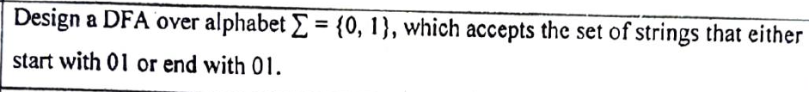

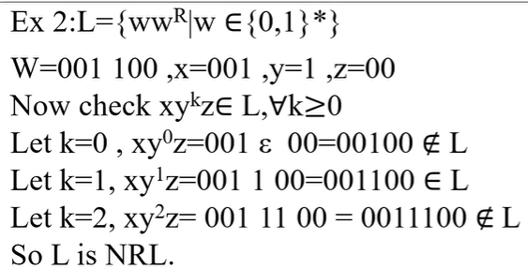

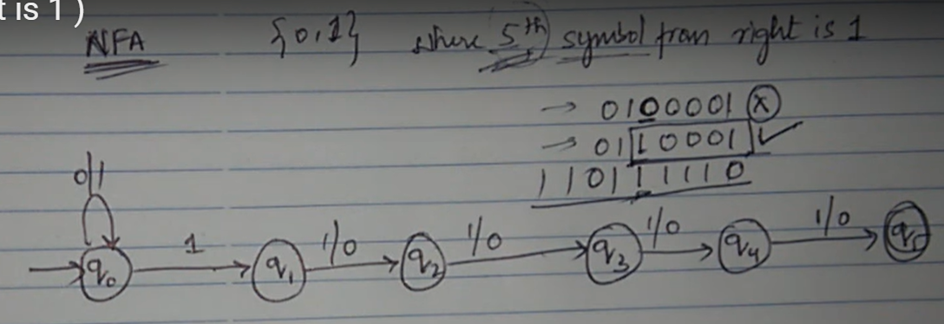

<https://www.youtube.com/watch?v=XwLY1Xwaq1s&ab_channel=EducationAboutStuff>



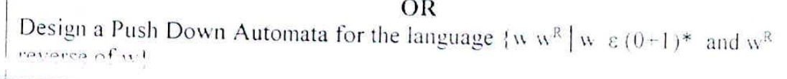

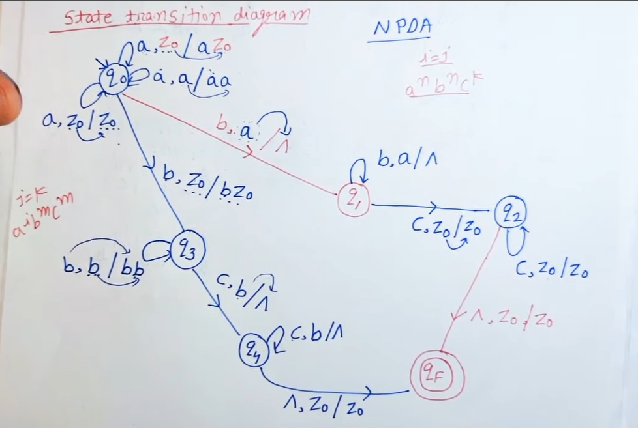

Design a Turing machine to copy the given number ‘n’ on the tape such that

Input: 0^n

Output: 0^n 1 0^n

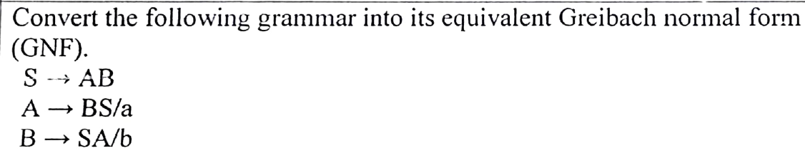

<https://www.youtube.com/watch?v=OkwFDCD0tYw&list=PL4x0v29DZ2pDq-5SI9KlYxPDKdYCcmgJm&index=100&ab_channel=ParnikaTutorials>

